MOBILE CONSULATE
DAY OF PROCEDURES: PASSPORT AND PROOF OF LIFE
SATURDAY, OCTOBER 23, 2021

PASSPORT RENEWAL INFORMATION IN SPANISH

YOU CAN RENEW YOUR PASSPORT ONLY IF:

- You have already had a passport processed since the year - 2013 . Since we do not process passport for the first time.
- Panamanian Cédula, can be valid or expired.
- If you do not have a cédula or never had acédula, youwill need to bring an ID where your name appears ONLY as you are registered on your birth certificate. The ID needs to have your signature and photo if you do not have a signature or photo you will not be able to carry out the procedure. In case you never obtained a Panamanian ID and are presenting ID you must have your Panamanian birth certificate.
- FORMINORS: Comply with the above requirements. Both parents must physically present themselves on the day of the Mobile Consulate Paperwork.

IF YOU MEET THE CRITERIA SET OUT ABOVE, YOU CAN PROCESS THE PASSPORT RENEWAL IF YOU BRING THE FOLLOWING REQUIREMENTS (bring a legible copy of each document since there will be no copier):

- Present yourlast passport and a legible copy. In case of loss, a passport loss form will besigned and delivered when the procedure is carried out.
- Present a Panamanian cédula and a legible copy,may be current or expired. If you do not have a cédula or never had a cédula, you can bring an ID where your name appears ONLY as you are registered on your Panama birth certificate. It is necessary that the ID has your signature and photo. In case you never obtained a Panamanian cédula you must present your Panamanian birth certificate in conjunction with the official ID of the city where you reside.
- IMPORTANT: FOR CHILDREN UNDER 18 YEARSOLD. All the above requirements apply including the requirements to follow (photos and money orders)
- Both parents must be present and sign the authorization form for renewal of passport for minor which will be provided on the day of processing.
- Parents must present identification, either: Panamanian ID, may be current or expired. Of not having a cédula. You can bring an ID where your name appears as you are registered in Panama. The ID needs to have your signature and photo.
- Panamanian birth certificate.

- Each person must submit> **2 photographs (size 2X2) in colors with white background. Photosmust meet the requirements.** PHOTOS THAT DO NOT FOLLOW THE AFOREMENTIONED CRITERIA WILL BE SUBJECT TO DENIAL BY THE PANAMA PASSPORT AUTHORITY.

**PHOTO REQUIREMENTS:
Two passport-size photographs (2X2 size) that meet ICAO requirements:
- Size (2X2) in colors.
- Make sure the background is completely white, not grayish or bluish.
- Posture and front view.
- Neutral facial expression, without smiles or without showing teeth.
- The TWO ears should be visible. Earrings for men or women are NOT allowed. No piercings.
- Hair accessories or high or extravagant hairstyles, tight hair and behind the shoulders and earsare notallowed.
- No bare shoulders, no band-aids, no visible neckline, no turtleneck. THE NECK SHOULD BE VISIBLE.
- No white or GRAY tops or pastel colors. Colors must be strong so that it stands out with the white background.
- No hoodies.
- No glasses, no colored contact lenses.

Disclaimer:We recommend following the requirements to avoid any inconvenience.
PHOTOS THAT DO NOT FOLLOW THE AFOREMENTIONED CRITERIA WILL BE SUBJECT TO DENIAL BY THE PANAMA PASSPORT AUTHORITY.
EXAMPLES
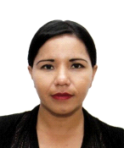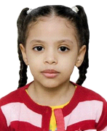

- Each person must file> Two(2) money orders. Money orders must be separate amounts:
PAYMENT METHOD SECTION
MODE OF PAYMENT BY MONEY ORDER FOR REGULAR PASSPORTS (passport of 32 pages)
1. Money Order of $110.00 payable to: SPECIAL PASSPORT FUND.
2. Money Order of $ 75.00 payable to: CONSULATE OF PANAMA.

PASSPORTS FOR OLDER ADULTS (passport of 32 pages) Women: over 55 years Men: over 60 years old
1. $60.00 money order payable to: SPECIAL PASSPORT FUND.
2. Money order of $ 75.00 payable to: CONSULADO DE PANAMA.

EXAMPLES OF MONEY ORDER FOR PASSPORT
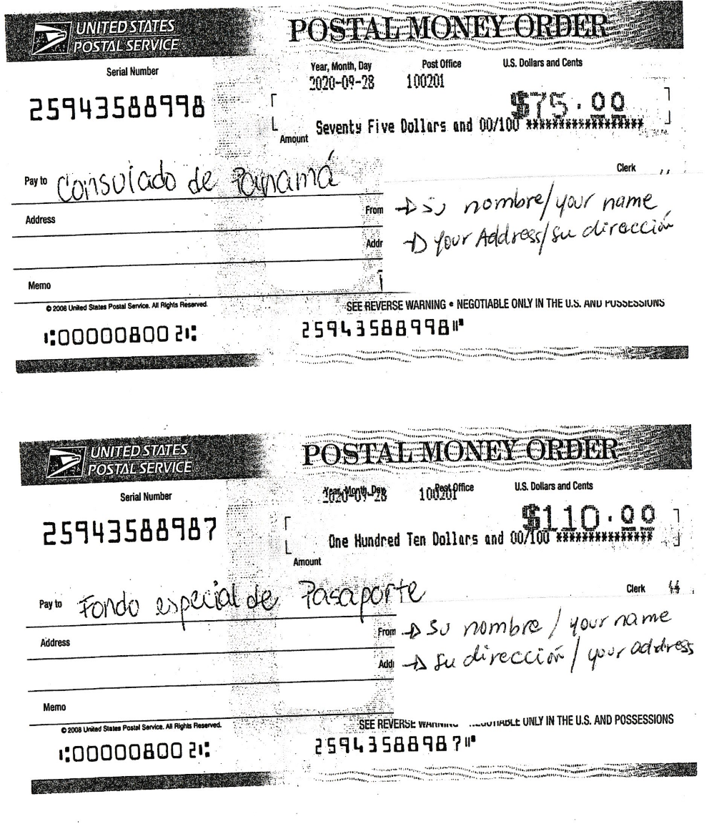
STUDS OR ERASURES ARE NOT ACCEPTED. ANY MONEY ORDER WITH ERROR WILL NOT BE ACCEPTED.
INFORMATION FOR THE PROCESS OF FAITH LIFE IN SPANISH

REQUIREMENTS FOR THE FAITH OF LIFE:
- Carnet de la Caja de Seguro Social. ORIGINAL or legible copy. If you do not have a Panamanian social security card, you must know your Panamanian social security number. Non-American.
- Document. ORIGINAL or LEGIBLE COPY. If expired, provide another ID such as passport or ID of the state that is still in force. If you use ID the name must appear as you are registered in Panama.
- Fill out completed application without studs or smudges. Only sign in front Do not sign before your appointment.

